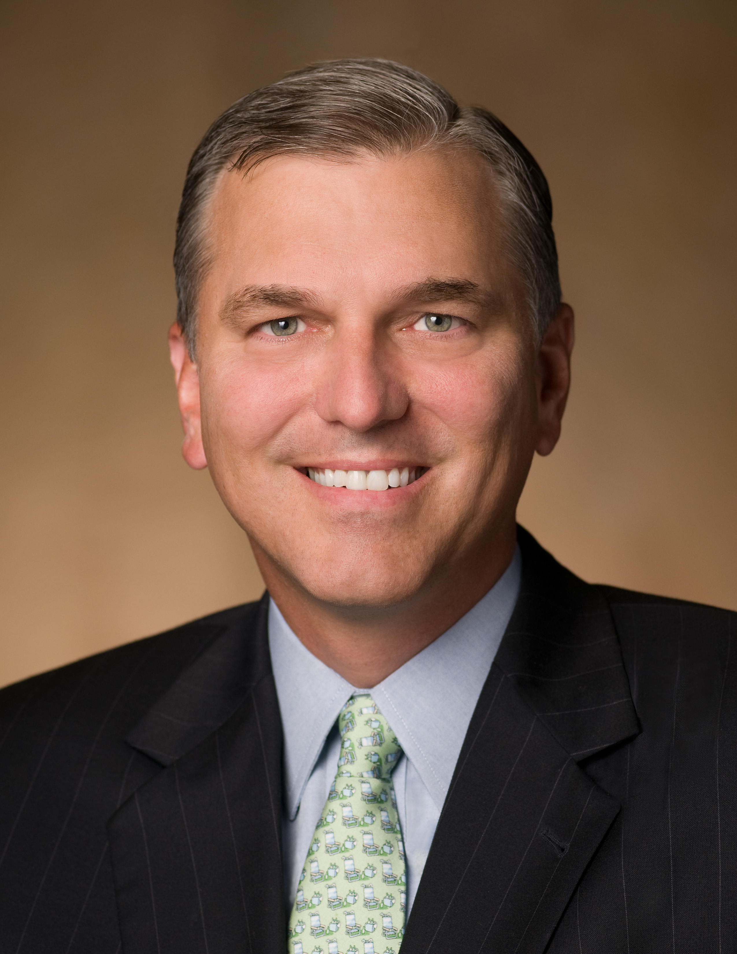
D. Cameron Findlay
Senior Vice President, General Counsel &
Corporate Secretary
Medtronic, Inc.

D. Cameron Findlay is Senior Vice President, General Counsel and Corporate Secretary of Medtronic, Inc. Medtronic is the world’s largest medical device company, with over $16 billion in annual revenue, 45,000 employees in 120 countries, and a Fortune-50 market capitalization. As Medtronic’s chief legal officer and head of government affairs, Findlay leads Medtronic’s 130-lawyer global legal department and its government relations department, and serves on the Medtronic Executive Committee as a senior member of the company’s management team. Under his leadership, the Medtronic Legal Department was named “Best Legal Department” in the nation by Corporate Counsel magazine in May 2012.

Before joining Medtronic in 2009, Findlay was for six years the Executive Vice President and General Counsel of Aon Corporation, the world’s largest insurance broker, with $10 billion in annual revenues and 50,000 employees in 120 countries. Prior to that, Findlay served from 2001-03 as the Deputy Secretary of the U.S. Department of Labor, the number-two official and chief operating officer of a cabinet department with a $70 billion budget, 17,000 employees and operating agencies such as OSHA, the Employee Benefits Security Administration, the Wage & Hour Division, and the Employment Training Administration. While in government, Findlay also served as the President’s appointee to the Board of Directors of the Overseas Private Investment Corporation and the Congressional-Executive Commission on China.
During the 1990s, Findlay was a partner at the global law firm Sidley Austin LLP, specializing in complex litigation for and advice to companies in the telecommunications and energy sectors and other heavily regulated industries. Before that, he served as a senior official at the White House during the administration of President George H.W. Bush, as Deputy Assistant to the President and Counselor to the White House Chief of Staff.
Findlay served as a law clerk for Justice Antonin Scalia of the U.S. Supreme Court from 1988-89 and for Judge Stephen F. Williams of the U.S. Court of Appeals for the District of Columbia Circuit from 1987-88.
Findlay is active with numerous civic and professional organizations. Findlay serves on the Board of Trustees of Northwestern University, chairs its Audit Committee, and serves on the Executive, Nominations, and Educational Properties Committees. He also serves on the Board of Directors of the Minnesota Orchestra, one of the world’s leading orchestras. He is a full member of the Council on Foreign Relations. While in Chicago, he also served on the Boards of the Chicago Council on Global Affairs, the Chicago Shakespeare Theater, and the Children’s Home and Aid Society, which he chaired.
Findlay received his bachelor’s degree summa cum laude and graduated first in his class from Northwestern University, his master’s degree with “First Class Honours” from Oxford University, which he attended as a Marshall Scholar, and his law degree magna cum laude from Harvard Law School.

He lives in Minneapolis with his wife Amy, a Harvard Law School classmate. They have two college-age sons, Alexander and James.

