**How to Put the LCLD Fellows Directory on the Home Screen of Your iPhone**

* On your phone, navigate to [www.lcldnet.org/fellows/directory/](http://www.lcldnet.org/fellows/directory/)
* Tap the top of the screen to bring up the options for the page, then select the “share” button (circled in red below).

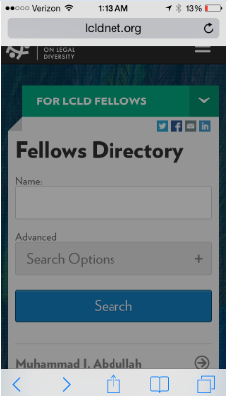

* Select “Add to Home Screen” (circled in red below).

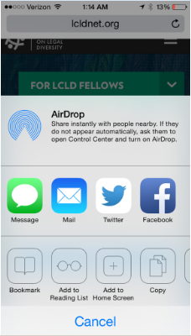

* Insert or edit the name you would like to give the icon on your home screen (in the space underlined in red below) and tap the “add” button (circled in red below).

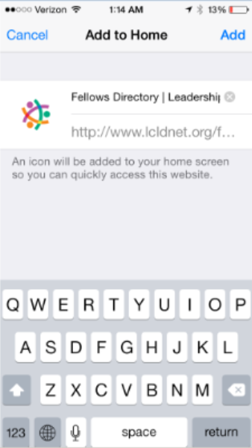

* Done! (Now, use it!)

